BOXYARD resto bar
(A Web Design Development Project)
Presented to
the Faculty of the College of Computer Studies
Our Lady of Fatima University
In Partial Fulfillment
of the Requirements for the
WBDV111 – Web Development with Lab I
By:
Kenneth A. Geopano
April 2026
TABLE OF CONTENTS
- Executive Summary
1.1 Project Overview
1.2 Target Audience
1.3 Project Objectives
1.4 Statement of the Problem
1.5 Scope and Limitations
- Introduction and Project Background
2.1 Business Profile
2.2 Rationale of the Web Design Project
2.3 Significance of the Project
- Planning and Design
3.1 Website Category and Concept
3.2 Design Goals and Visual Strategy
3.3 Site Map and Information Architecture
3.4 Wireframe and Page Layouts
3.5 Navigational Design
- Design Implementation
4.1 Homepage Design
4.2 Inner Pages Design
4.3 User Interface Design Elements
4.4 User Experience Considerations
4.5 Branding and Visual Consistency
- Summary, Reflection, and Recommendations
5.1 Project Summary
5.2 Self-Reflection
5.3 Future Design Improvements

- EXECUTIVE SUMMARY
1.1 Project Overview
This project focuses on the design and development of the BOXYARD Resto Bar website, a modern and responsive platform that showcases a premium dining and nightlife experience. The website serves as a digital presence where users can explore services, view menu offerings, and make reservations online.
1.2 Target Audience
The target audience includes young professionals, food enthusiasts, and individuals who enjoy nightlife experiences such as live music, fine dining, and craft cocktails. It also caters to users who prefer accessing services and making reservations online.
1.3 Project Objectives
The main objectives of the project are:
- To create a strong online presence for BOXYARD Resto Bar
- To provide a convenient reservation system for customers
- To present menu offerings and services in a visually appealing way
1.4 Statement of the Problem
Many restaurants and bars face challenges in reaching a wider audience and managing customer reservations efficiently without an online platform. Customers may also lack access to important information such as menu offerings and services.
1.5 Scope and Limitations
The project includes the front-end development of the Home, About, Menu, Reservations, and Login pages. It is limited to a static website and does not include back-end functionalities such as database integration or real-time booking confirmation.

- INTRODUCTION AND PROJECT BACKGROUND
2.1 Business Profile
BOXYARD Resto Bar is a modern dining establishment that combines fine dining, craft cocktails, and live entertainment. It provides a stylish and upscale environment ideal for social gatherings and nightlife experiences.
2.2 Rationale of the Web Design Project
The purpose of this project is to create a digital platform that reflects the brand identity of BOXYARD Resto Bar. The website allows customers to easily access information and make reservations, improving overall convenience and accessibility.
2.3 Significance of the Project
The website enhances customer engagement and supports business growth by offering an accessible platform for browsing services and making reservations. It also helps the business stay competitive in the digital era.

- PLANNING AND DESIGN
3.1 Website Category and Concept
The website belongs to the Food and Beverage category, specifically a resto bar concept. The design emphasizes a modern, elegant, and nightlife-inspired aesthetic.
3.2 Design Goals and Visual Strategy
The design uses a dark-themed interface combined with gold accents to create a luxurious feel. Clean layouts, large typography, and visual hierarchy are applied to improve readability and user interaction.
3.3 Site Map and Information Architecture
Home
│
├── About
├── Menu
├── Reservations
└── Login
3.4 Wireframe and Page Layouts
The homepage layout consists of a fixed navigation bar, a hero section with a strong headline and call-to-action button, and a footer. The layout is structured to guide users toward making a reservation efficiently.
--------------------------------------------------
| 🍸 BOXYARD Resto Bar Home About Menu Login |
--------------------------------------------------
| |
| Savor the Night |
| Fine dining • Cocktails • Live music |
| |
| [ Reserve Table ] |
| |
--------------------------------------------------
| Ready for a great night? |
| [ Reserve Now ] |
--------------------------------------------------
| Footer |
| Contact | Address | Social Links |
--------------------------------------------------

3.5 Navigational Design
The website uses a fixed navigation bar at the top of the page, allowing users to easily access different sections. The navigation is responsive and adapts to various screen sizes for better usability.

- DESIGN IMPLEMENTATION
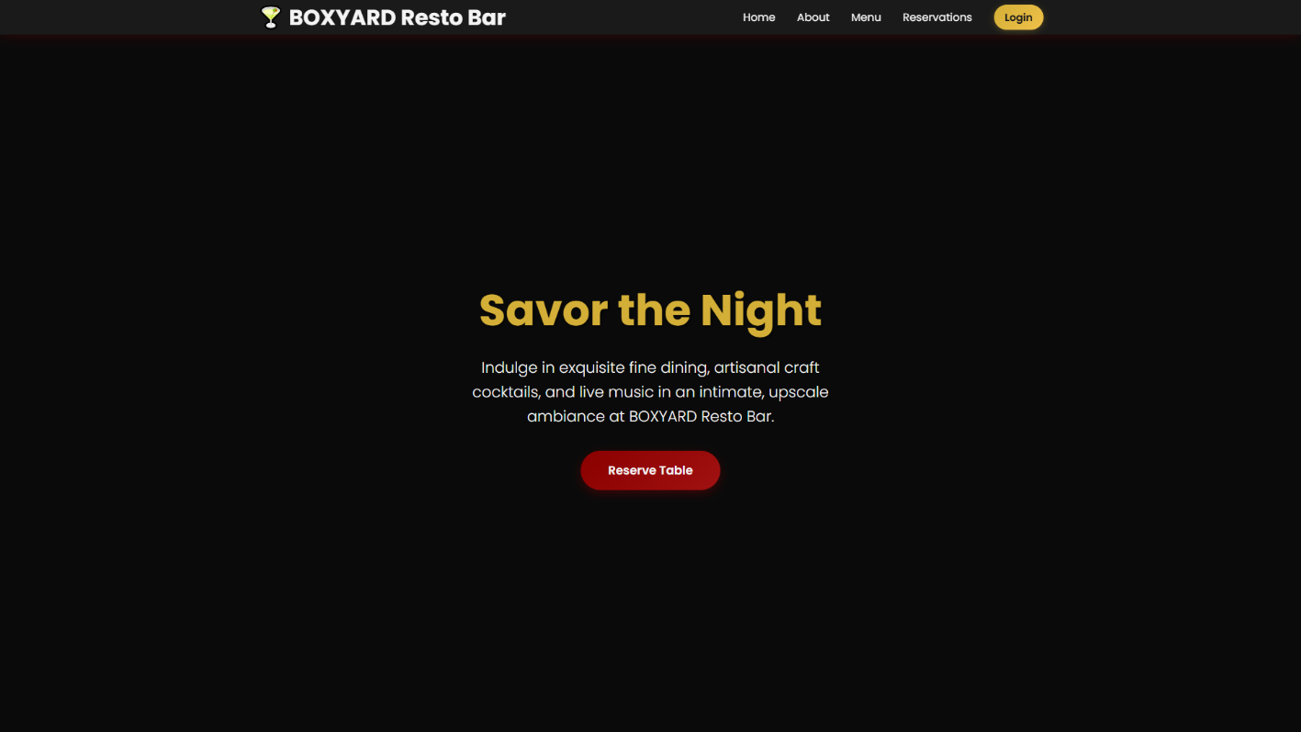
4.1 Homepage Design
The homepage features a large hero section with the headline “Savor the Night,”
accompanied by a short description and a “Reserve Table” button. This section serves as the focal point and encourages user interaction.
4.2 Inner Pages Design
- About Page: Provides background information about the resto bar and its ambiance
- Menu Page: Displays specialties such as fine dining, craft cocktails, and live entertainment
- Reservations Page: Includes a form where users can book a table
- Login Page: Provides access to user accounts (for future development)
4.3 User Interface Design Elements
The interface includes interactive buttons, form inputs, hover effects, and card-based layouts. These elements enhance visual appeal and improve usability.
4.4 User Experience Considerations
The website is designed with simplicity and usability in mind. Users can easily navigate
through pages, access information, and complete actions such as reservations without difficulty.
4.5 Branding and Visual Consistency
Consistency is maintained through the use of colors, typography, and layout across all pages. The dark theme and gold accents reinforce the premium branding of the resto bar.

- SUMMARY, REFLECTION, AND RECOMMENDATIONS
5.1 Project Summary
The BOXYARD Resto Bar website successfully presents a modern and responsive design that aligns with the brand’s identity. It provides users with an efficient way to explore services and make reservations.
5.2 Self-Reflection
The Creative Process
I chose a resto bar website because I wanted to create a modern and visually appealing design that focuses on user interaction and layout structure. I am most proud of the hero section and overall design theme, which reflects a premium and elegant atmosphere.
Technical Growth
One of the most challenging aspects was styling layouts using CSS, especially positioning elements and creating responsive designs. I improved by experimenting with different CSS properties and practicing layout techniques. If given more time, I would add animations and dynamic features such as a reservation system with real-time updates.
Problem Solving
One issue I encountered was aligning elements properly in different screen sizes. I resolved this by adjusting CSS properties and using responsive design techniques. During testing, I realized the importance of simplifying the layout to improve user experience.
Future Outlook
I would rate my confidence in HTML and CSS as 8 out of 10 because I can now build structured and styled web pages independently, although I still want to improve in advanced features.
5.3 Future Design Improvements
- Integration of a database for real-time reservations
- Implementation of user authentication system
- Addition of live chat support
- Enhanced animations and interactivity

